- Open the website: http://www.materials-conference.com/registration.html
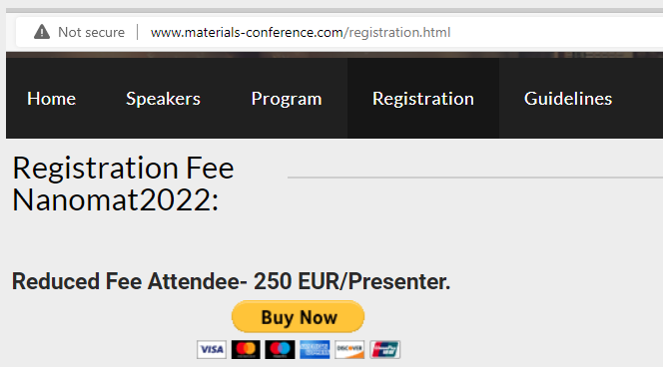
2. Click the button Buy now.
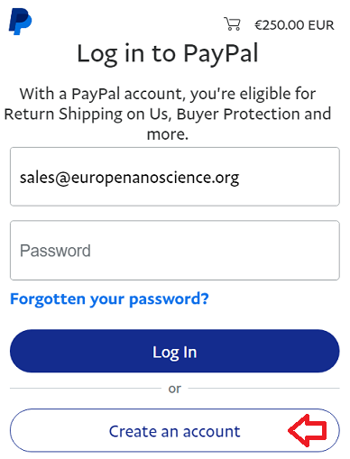
3. Select ‘’Create an account’’ even if you don’t need a Paypal account.

4. Type your debit/credit card details. Payment is secured by PayPal. You have an option below to choose not to open a Paypal account. Payment is done through debit/credit card.
