MEMBERSHIP FORM | EUROPEAN NANOSCIENCE and NANOTECHNOLOGY ASSOCIATION  Str. G.S. Rakovski 111, Sofia 1000, Bulgaria
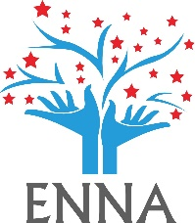

Applicant Information | First Name: | Last Name:
 | email address: | Phone number:
 | City: | Country:
Employment Information | Company or Institution:
 | Department:
 | Address:
Types of Memebership | Student Member – 20 EUR  Any individual pursuing an undergraduate/graduate or an individual with a PhD/MSc or equivalent in any of the disciplines associated with or integral to nanoscience and nanotechnology. | Professional Member – 25 EUR  The professional member of the society will get reduced cost for participation in ENNA events

Become a member and get discount for 2024 NANOMAT CONFERENCE:
- Student membership - discount from registration fee 30 EUR
- Professional membership - discount from registration fee 40 EUR

Signature of applicant:

